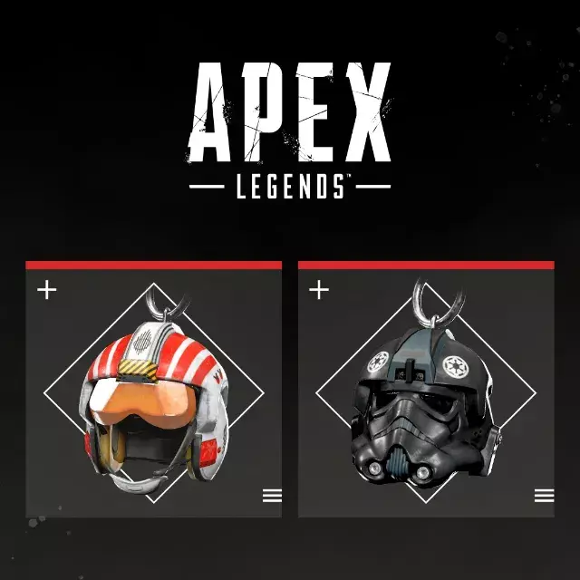

*Apex Legends:*

1️. **Unique Legends & Abilities**

* Each character has **special abilities**, from **healing drones (Lifeline) to portals (Wraith)**, adding strategy to gunfights.

2️.**Fast-Paced Battle Royale & Squad-Based Gameplay**

* 60-player **battle royale with trios or duos**, focusing on **teamwork and survival**.

3️.**Advanced Movement & Gunplay**

* Features **sliding, climbing, ziplines, and redeploy balloons** for high-mobility combat.

4️. **Diverse Maps & Rotating Game Modes**

* Includes **World’s Edge, King’s Canyon, Olympus, Storm Point, and Broken Moon**, along with **Arenas and limited-time events**.

5️.**Free-to-Play with Seasonal Content**

* Completely **free-to-play**, with **cosmetics, new Legends, and maps added in seasonal updates**.